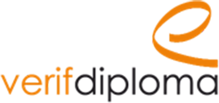

«Company name» carry out verification of the diplomas of the candidates recruited

You want to integrate «Company name» and you are committed to providing accurate information. In order to guarantee the fairness of treatment between the candidates, we make sure to recruit only the candidates who actually have the diplomas declared during the application.

Also, we thank you in advance for kindly completing and signing this authorization allowing us, with your agreement, to carry out the necessary verifications, which will not be heard realized only if your recruitment is registered.

I, the undersigned

Name (first, last):

Date of birth DD/MM/YYYY :

authorize « University name » to confirm the authenticity of my degree.

Title of the diploma :

Graduation year :

to Verifdiploma on behalf of «Company name»

Date :

signature :

